  - Strokes Unfolding Unexplored World

A popular Marathi news paper publishes Sunday edition for kids, which carries drawings and sketches by children mostly from Pune and surrounding suburbs. Objects of their interest and curiosity are usually reflected through these drawings such as birds, animals, vehicle, popular characters in cartoon series and often countryside scenery which is typically based on imagination or weekend outdoor visits. Children from primary and higher primary are observed to be sending the drawings though drawings by secondary level children are very rare. It seems children of higher age group do not waste (!) their time in such activities as they have more important academic subjects like science and mathematics to concentrate on, keeping in view their future career.
The drawings published in newspaper are fairly good; however they hardly reflect the imagination, thought process and world of experience of the creators. I have a series of drawings which if you get to see without knowing the background of their creators, you would not believe that they are drawn by the children in the age group of 10 to 14 years. These are the drawings by children from tribal ashram schools in Nandurbar district in Maharashtra. They have expressed their world – a area in which they dwell, their customs, festivals, their environment and of course from their point of view, which is otherwise quite rare. It was encouraged by triggering their imagination and creativity on certain topics which were selected in consultation with them. The maturity, the expertise and the skill expressed in these drawings is amazing.
It would be interesting to discuss different aspects which are transported through the said series of drawings by children from Bhil and Pawara tribe.

- Realistic style of drawings
I have seen the drawings and paintings on the walls of Bhil and Pawara tribe in this region. Unlike Warlis or few other tribes, who draw symbolically Bhil and Pawara drawings are realistic. Drawings by school children are also much closer to reality not just in terms of appearance but also proportion. Some drawings are so accurate that one could take them as photo-prints.
In some of the more complicated drawings reality is intermingled with imagination. I remember one drawing narrating the entire story of the race between the hare and the tortoise, in just three images. The hare was drawn with one tortoise ahead and another one behind him on the background of a jungle. With a tricky bend of the race track, two different situations in the race were indicated. Then there is a drawing on tribal marriage, depicting entire wedding ceremony right from starting of Barati from groom’s house to last event of dance at bride’s home on a single paper.

- Collective Thought and Combined Action
Tribal are known to live community life. Most of their activities are done collectively as a whole community. They sing as a community, dance as a community hunt as a community and even enjoy the feast of hunt as a community. The drawing efforts in schools made us realize that they can even draw and paint as a community with high level of coordination. It definitely involves a skill / competency of collective thinking and collective action.

A friend of mine happened to see a drawing of Gav Bazar(page 5). She was doing her Ph. D. in some aspect related IQ of the children. She herself is a good sketcher. She wondered about the level of IQ of the child who drew this sketch. She stated that it’s not an easy task to cover such a great span in a single drawing especially by a school going child. I shared that it’s not a drawing by a single child, it’s a group drawing. She could not believe that a group of 3-4 children could work on a single canvas and create such a fine, brilliant work. She was amazed by the collective intelligence reflected not just in catching the extensive details of the place but also by high level of coordination while drawing a single scene by many.

It has been exhibited long ago in our carved caves of Ajantha and Ellora where carving of similar style has been done in several caves. However, lot remains to be explored in the field of collective intelligence and its united expression.

- This is how the children of Satpuda, view the world around
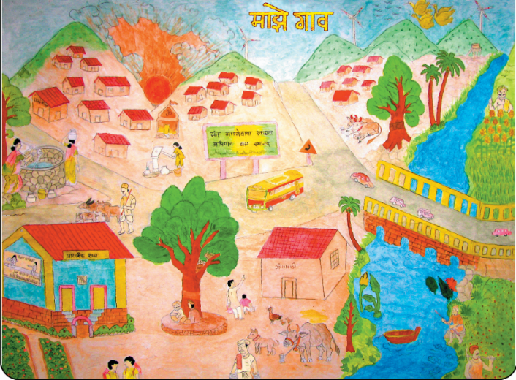
Most of these children dwell in ranges of Satpuda, a range of mountains on north border of Maharashtra. It’s likely that very often they see the world around from the top. Obviously, top view is presented very effectively in their drawings.
My Village
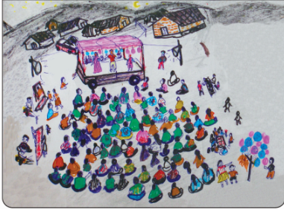

Many of the drawings also give long shot along with top view if it is to be expressed in cinematic terminology. They cover a wide range of things in the surrounding, a clear indicator of the span of their observation.
A Songadya party (musical drama) on the occasion of Gav Diwali

It also speaks about the wider and inclusive outlook towards the surrounding. The mountains, river, trees and different other non-human inhabitants are also inevitable part of a particular scene. Not just the scene of the village but even the scene of a musical

drama on the occasion of Gav Diwali also covers ranges of mountains around the village because this is how it exists along with and very much among the nature.

- Minute details
The extent of specification and accuracy in detailing surprises us even more.

Again I would refer to above drawing of My Village and Songadya Party on Gav Diwali. It shows minute detailing which can only come out of keen observation and thoughtful presentation of a plot, time, situation etc.

My Village - A road which comes across the hills is passing by the village. We can see a small signboard just behind the S. T. bus which indicates a turn / a divergent road going towards village. S. T. stand carries a nameplate. Among scattered habitation, one can make out a small temple. Sketches of people engaged in different activities / chores give the feel of village life. The school building carries a promo of Sarva Shiksha Abhiyan which by default is seen on every school building in villages. In a maximised version of the picture you could see a small bird on a tree which is standing next to the school. A bird is sitting beside its nest which carries three-four eggs. And then towards the horizon alongside the windmills one can see flying birds probably migratory.

Songadya Party on Gav Diwali - Songadya party i. e. musical drama performed at the occasion of Gav Diwali. It traditionally is performed at nights. One can figure out from the use of colour schemes that the time presented in a drawing is night. The calm and quiet background of mountains and houses highlights the happening activity on the stage. The performance venue is surrounded by various vendors who are busy selling their goods even at night. Just before the balloon seller, there is small group sitting around a rectangular shaped board. They are enjoying gambling on cards.

Interestingly, not a single person in the mob which is facing their backside is like other.
Though human beings are rejoicing at night, stray animals roaming on the road are following natural course of action, therefore none of them is observed in this drawing.
This drawing speaks a lot about the capacity and quality of observation of these children.

Here is another wonderful drawing of Gav Bazar i. e. Village market which provides the vivid view of everything that is found in and around village Bazar.
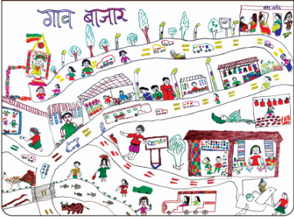

It shows different lanes in the market with minute details of the saleable items in every shop. Thus one can make out cloth shop in the right corner of the upper lane followed by sweet shop, vegetable and fruit shop, next to it is gutkha shop and then toy shop in the left corner of the upper lane, while in the lower lane one can see jewellery shop in the right corner. Though sale of gutkha is prohibited by law, it is sold illegally in the open market in villages. This sad reality is reflected in this drawing.

Market also shows the surrounding with extensive details. It has bus stand in north east corner and one can see people waiting for the bus. While in north-west corner, there is a temple of a village deity, with flower decoration around the temple. Different kinds of vehicles – motors, bus, cars, jeeps, trucks are running on the road. Along with pedestrians walking along the road, different animals are also roaming around. Two girls are busy fetching water from the hand-pump in south-east corner of the drawing. Three children are busy in planting saplings alongside the river. Fish and snakes are swimming into the river quite extrovertly. Their apparent presence may be out of the effort to emphasis their existence in the river.

Extra ordinarily big span of the village market is covered in this drawing!

- Few strokes of lines present a complete picture at a glance

There are few other drawings which surprise you in another way. Just few strokes of lines explain much broader concept or content to you. Very few but perfect features explain the topic.

Following drawing presents a comparative picture of market places in city and village.

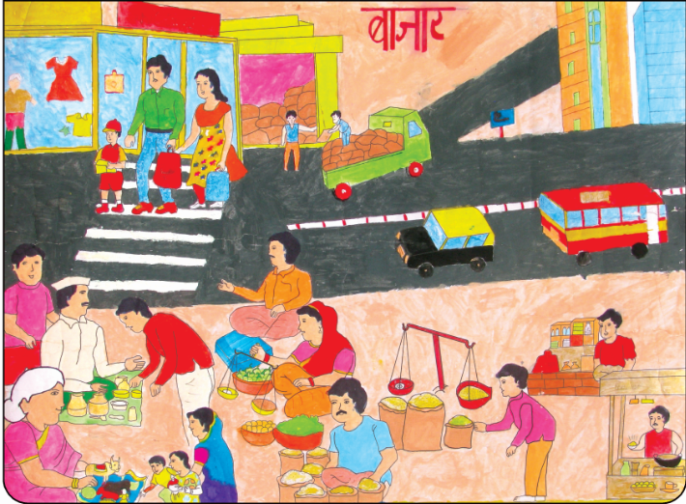
A tar road with zebra crossing lines, a mall exhibiting fashionable wears behind the glass wall, a big storage room and sky touching buildings indicate the typical features of city.

While people sitting on the mud floor selling their goods, mostly grocery items of daily use in cane baskets indicate a simple market place in a village. The different dressing pattern of people further emphasises the difference of culture of both the places.

Above drawing shows clear difference in the culture of urban and rural areas while there are few other drawings which represent intermingling of both the cultures. Singing and dancing on different occasions is an integral part of tribal culture however use of modern, urban technology like loudspeaker and electric banjo is influence of non-tribal culture which has been assimilated in traditional ways of celebration by now.

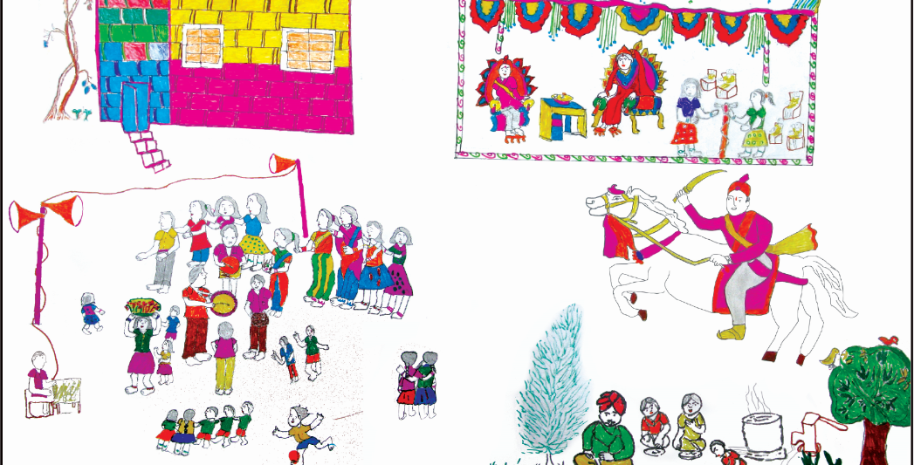
One can see young girls and boys dressed in modern style and with modern hair styles are dancing in a traditional way on the occasion of a marriage. A girl wearing skirt-blouse is carrying a ‘Shibli’, a decorated cane basket, which has cultural importance at the time of marriage, on her head. Musical rhythm is being given by electrical banjo along with traditional ‘tasha’ and loud speakers are adding to the mood of enjoyment.

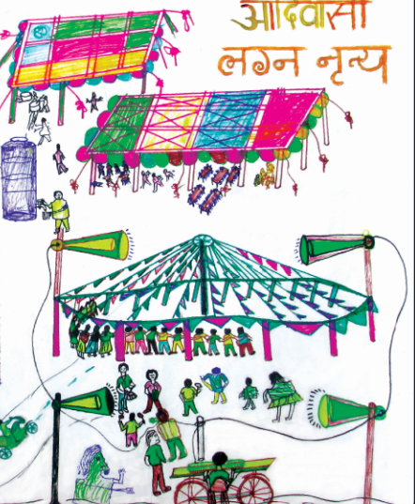
Predominant sketching of loud speakers in this drawing shows the increasing space occupied by this modern notorious technology even in the life of rural-tribal folks and replacement of traditional variety of musical instruments by unique one.
- Reflection / Documentation of Local Culture

These drawings have also proved to be a source of visual documentation of tribal culture, that is carrying a threat of extinction to a great extend under the pressure of urbanization and so called modernity.

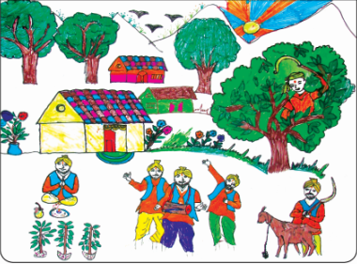
Following drawing presents a performance of a ritual, called ‘Indal’ among Pawara tribe in north Maharashtra. It is performed to express gratitude after a wish uttered in front of God is fulfilled (Manata).

The drawing explains three main rituals of Indal. A person is performing Pooja, of three small branches and three other men are playing musical instruments and singing. One can see a boy cutting a branch of a tree in the background. Not grownups but a young boy is supposed to cut the branch. These are branches of a tree called ‘Kamba’ or ‘Kumban’, which are worshiped ritualistically.

Another man is standing behind a goat with long sickle in his hand. This indicates another part of ‘Indal’ i. e. sacrificing goat.

People dance and sing over the night and branches of Kumban are drawn into the river in the morning.

All these men have beards. It explains a custom related to this ritual i. e. men performing Indal Pooja, who are called ‘Valava’, ‘Balava’ and ‘Fuvanya’, have to observe few rules or they have to live restrained life for a week before performing Pooja. They don’t sleep on the bed, they don’t eat food cooked at home and also don’t eat non-vegetarian food or drink liquor. They don’t use foot-wears and don’t even shave.
Here is another drawing, which documents a marriage ritual which is typically observed among tribal communities.
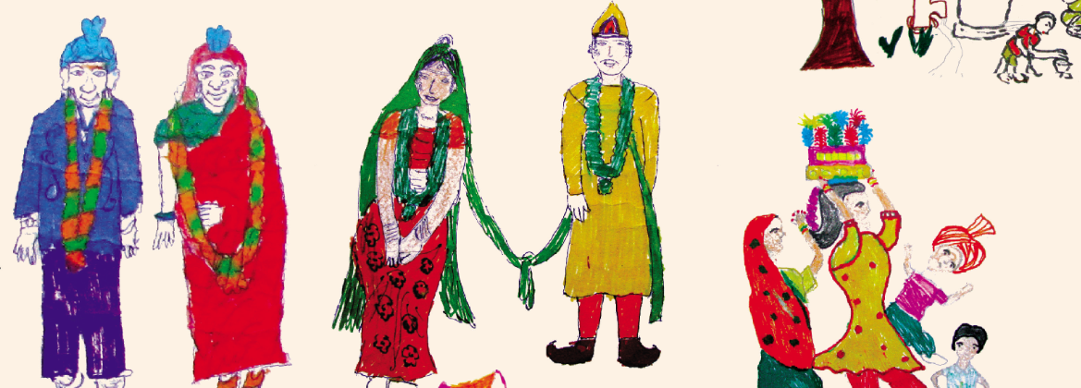
The couple in the left catches the eye with its strange aged look, especially in comparison with a couple in the centre which is looking young and cheerful. It’s not due to the immaturity or lack of skill of the artist. The newly married couple in the left is actually supposed to look aged. Among tribal, if a boy and girl abscond and start living together without marriage, when it comes to the marriage of their children, the parents have to get married a day before the marriage of their children. Then only, the marriage of their children is accepted socially.

- Multiple Intelligence reflected in the drawings
Theory of Multiple Intelligence proposed by Harward Gardner provides a list of 8 types of intellectual abilities. These drawings show high level of visual intelligence which involves spatial judgement and ability to visualize mind’s eye.
Drawings which are a result of collective effort also express excellent interpersonal intelligence. Often interpersonal intelligence is mistaken for extrovert personality. In a true sense it is an ability to cooperate in order to work as a part of a group. It would be interesting to study whether tribal children are more likely to acquire this ability through their socialization process which emphasizes to live as a part of a community.
Nature has been an integral part of different life situations which have been depicted in the drawings. Further analysis of drawings may throw light on how do children perceive and/or interpret the existence of natural phenomena in human life. It would give some clue about the naturalistic intelligence among these children.
End Note
These drawings should be valued as a resource to enter into the world of tribal children. The world of children itself is an ignored, unexplored area in India. Further, there is hardly any possibility that, the world of tribal children, who are known for their mute, suppressed existence is searched. Rather than verbal interaction, they would prefer to express themselves through medium of arts – drawings, sculptures, songs and dance. Tribal especially new generation while standing at the threshold of change, in the phase of transition which has been introduced and enforced by education system and changing economy, it would be interesting to study what do they carry forward from old culture, the outlook which is undergoing transition, how are they influenced by outer socio-economic forces and their responses to the same.

The drawings by tribal children should be valued as a resource to enter into their world. The world of children itself is an ignored, unexplored area in India. Further, there is hardly any possibility that, the world of tribal children, who are known for their mute, suppressed existence is searched. Rather than verbal interaction, they would prefer to express themselves through medium of arts – drawings, sculptures, songs and dance. Tribal especially new generation while standing at the threshold of change, in the phase of transition which has been introduced and enforced by education system and changing economy, it would be interesting to study what do they carry forward from old culture, the outlook which is undergoing transition, how are they influenced by outer socio-economic forces and their responses to the same.

Standard regional language in Maharashtra State in India
A mega city
A district on north border of Maharashtra state dominated by tribal population mostly Bhil and Pawara
Procession celebrating event of marriage
Village market
Local festival
The educational programme run by GoVT. It means a movement to education all.
A good used for intoxication
Musical instrument
A traditional musical instrument for rhythm like drum
Worship rituals

