Figures

Figure 1: Crop exchanges by variety

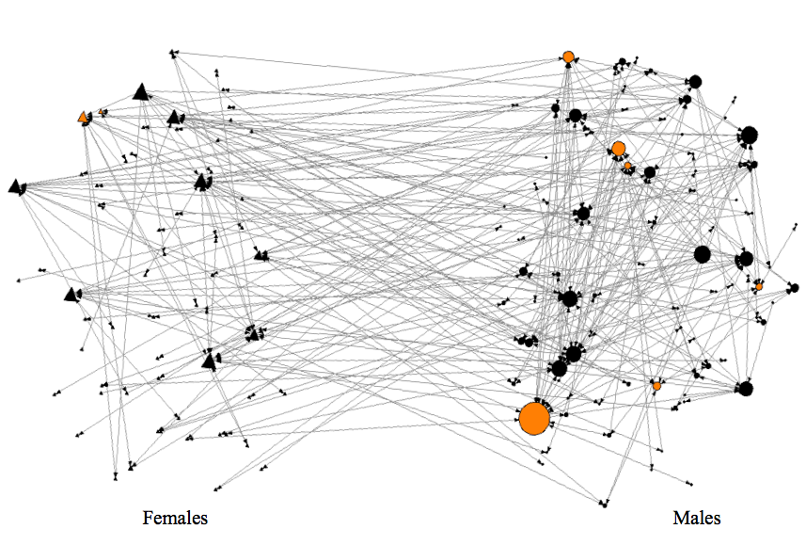
Figure 2: Gendered modern variety use. Each tie represents a crop seed exchanged between two farmers. The triangles represent female farmers, while the circles represent male farmers. The black nodes represent farmers who do not use any modern seed varieties, while the gray nodes indicate modern variety use. Note, farmers who use modern varieties tend to use amix of modern and tradtional seed.

Tables

Table 1: Descriptive statistics
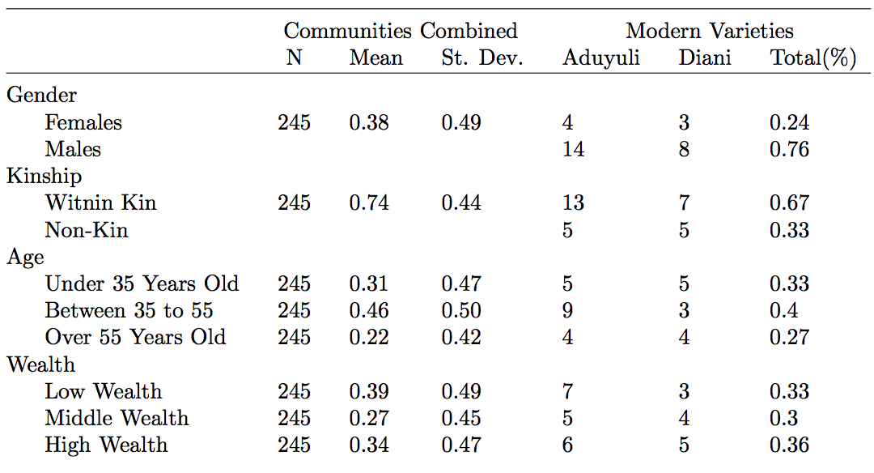

Table 2: Trade relationships
