Indigenous Knowledge and Prospects for Income and Employment Generation: The Case of Handicraft Production among Rural Women in Tanzania

TABLES IN TEXT

Table 1: Head Count Ratio by Area
Area | Head count  (2007) | Head count  (2011/12)
Rural | 39.4 | 33.3
Other Urban Areas | 22.7 | 21.7
Dar es Salaam | 14.1 | 4.1
Source: National Bureau of Statistics (2013), 2011/2012 Household Budget Survey.

Table 2: Distribution of Poverty (in %) by Activity Status of the Household Head in the 12 months before the Survey, Tanzania Mainland, 2011/12
Activity Status of Head | Food Poverty | Basic Needs Poverty
Employee | 1.4 | 10.0
Self-employed with/without employees | 11.2 | 31.0
Unpaid family helper in business | 0.0 | 41.8
Housewife | 10.8 | 27.8
Student | 9.4 | 25.1
Long term unemployed | 7.2 | 23.6
Retired | 0.5 | 4.7
Too old/Disabled | 11.6 | 43.0
Other | 10.1 | 27.0
Total | 9.7 | 28.2
Source: National Bureau of Statistics (2014), Tanzania Household Budget Survey Report.

Table 3: Employment Status, by Gender, 2006
Employment Status | Male (%) | Female (%) | Total (%)
Paid employee | 15.3 | 6.1 | 10.5
Self-employed (non-agricultural) with employees | 2.6 | 1.0 | 1.8
Self-employed (non-agricultural) without employees | 10.0 | 8.2 | 9.1
Unpaid family helpers (non-agricultural) | 1.5 | 5.3 | 3.5
Unpaid family helpers (agricultural) | 8.1 | 7.7 | 7.9
Work on own farm | 62.4 | 71.7 | 67.2
Total | 100.0 | 100.0 | 100.0
Source: Ministry of Finance (2010), Tanzania Gender Indicators.
Table 4: Respondents by Gender of Household Head and Occupation
Region | N | Gender of Household Head |  | Occupation/Activity
 |  | Female | Male | Handicrafts | Farming/livestock
Dodoma | 69 | 69 | 0 | 29 | 40
Iringa | 46 | 14 | 32 | 21 | 25
Mbeya | 80 | 28 | 52 | 37 | 43
Total | 195 | 111 | 84 | 87 | 108
Source: Survey data.

Table 5: Costs and Earnings by Activity
 | Obs. | Mean | Std. Dev. | Min | Max
Handicrafts
Cost of Inputs | 65 | 24675.8 | 80346.04 | 1000 | 650000
Operating expenses | 16 | 23700 | 26415.2 | 1200 | 77000
Average income per month | 75 | 59986.7 | 80559.3 | 5000 | 600000
Belong to a group |  | 132833.3 | 164521.8 | 30000 | 600000
  12 | 164521.8 | 30000 | 600000
Did not belong to a group | 62 | 46653.2 | 41596.6 | 5000 | 200000
HH expenditure per month | 72 | 61569.4 | 57480.2 | 10000 | 300000
Farmers/livestock keepers
Cost of Inputs | 76 | 69177.6 | 93161.8 | 1000 | 500000
Operating expenses | 25 | 220166.6 | 295451.9 | 6000 | 1100000
Average income per month | 84 | 195109 | 335876.2 | 5833 | 2500000
HH expenditure per month | 81 | 112820.6 | 82753.03 | 10000 | 380000
Groups
Cost of Inputs | 4 | 565000 | 491629.9 | 90000 | 1170000
Operating expenses | 4 | 211250 | 309848.8 | 30000 | 675000
Average income per month | 4 | 960000 | 1403519.0 | 180000 | 3060000
Source: Survey data.

Table 6: Income Statistics
Mean | Median | Skewness | Kurtosis | Variance | Standard Deviation
11.001 | 10.819 | 0.401 | 2.972 | 1.393 | 1.180
Shapiro-Wilk W test for normal data
Variable | Obs | W | V | Z | Prob>z
lnavgincome | 159 | 0.984 | 2.006 | 1.583 | 0.057

Table 7: Regression Results
 | Coef. | Std. Err. | t | P>|t| | [95% Conf. Interval]
age | 0.078** | 0.031 | 2.51 | 0.013 | 0.016 | 0.139
age2 | -0.001** | 0.000 | -2.32 | 0.022 | -0.001 | -0.000
married | 0.402** | 0.175 | 2.30 | 0.023 | 0.056 | 0.747
noeduc | -0.052 | 0.196 | -0.27 | 0.790 | -0.439 | 0.334
hand | -0.708*** | 0.168 | -4.22 | 0.000 | -1.039 | -0.376
saver | 0.590*** | 0.197 | 3.00 | 0.003 | 0.202 | 0.979
inheritall | 0.665*** | 0.185 | 3.60 | 0.000 | 0.299 | 1.030
sellerhus | -0.947** | 0.381 | -2.49 | 0.014 | -1.700 | -0.194
cons | 9.249 | 0.828 | 11.18 | 0.000 | 7.613 | 10.886
Statistics: Number of obs = 147; F (8, 138) = 9.40; Prob > F = 0.000; R-squared = 0.353;
Adj R-squared = 0.315
Note: Dependent variable is lavgincome (log of average monthly income); ***;**;* - significant
at 1%, 5% & 10% respectively.

FIGURES

Figure 1: Highest Level of Education Attained: Handicraft Producers

Source: Survey data.

Figure 2: Highest Level of Education Attained: Farmers/Livestock keepers

Source: Survey data.

Figure 3: Ease of Accessing Health Services by Region

Source: Survey data.

Figure 4: Ease of Accessing Education and Training Services by Region

Source: Survey data.

Figure 5: Reasons for Engaging in Handicrafts

Source: Survey data.

Figure 6: How Handicraft Skills are Acquired

Source: Survey data.

Figure 7: Histogram Overlaid with a Normal Distribution
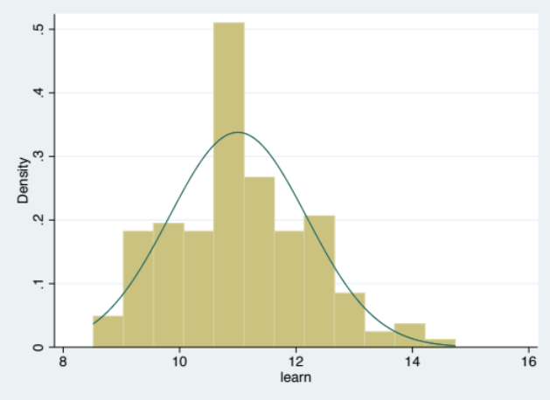
Source: Survey data.

Figure 8: Kernel Density Estimate Overlaid with a Normal Distribution
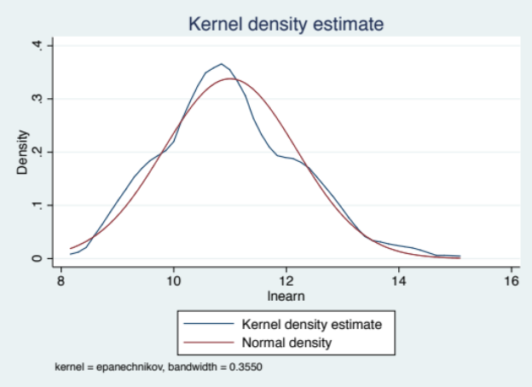
Source: Survey data.

TABLES & FIGURES IN APPENDIX

Figure A1: Map of Tanzania
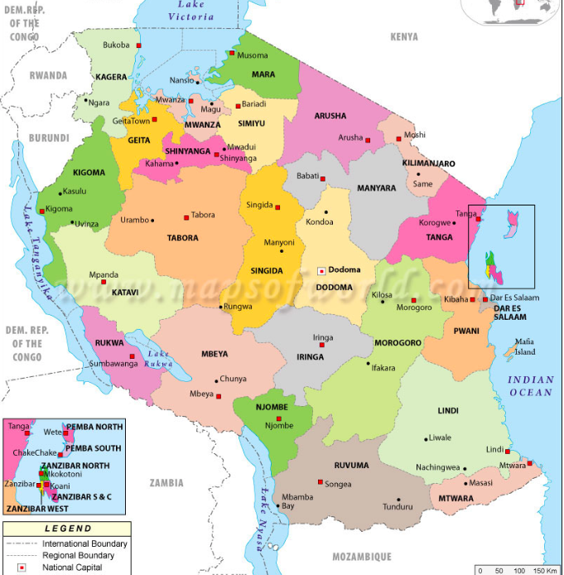
Source: http://www.mapsofworld.com/tanzania/tanzania-political-map.html

Table A1: Percentage* Distribution of Working Age Population (Ages 15 Years and Above) by Area, Level of Education and Sex, 2014
Area | Level of Education | Male | Female | Total
Dar es Salaam | Never attended | 2.23% | 0.01% | 4.29%
 | Pre-primary | 0.04% | 0.02% | 0.03%
 | Primary | 52.13% | 57.17% | 54.74%
 | Secondary | 35.60% | 30.15% | 32.75%
 | Tertiary | 10.06% | 6.48% | 8.19%
Other Urban | Never attended | 4.10% | 11.39% | 7.99%
 | Pre-primary | 0.02% | 0.01% | 0.02%
 | Primary | 60.05% | 60.87% | 26.25%
 | Secondary | 28.95% | 23.89% | 26.25%
 | Tertiary | 6.87% | 3.84% | 5.25%
Rural | Never attended | 15.27% | 29.96% | 22.81%
 | Pre-primary | 0.13% | 0.08% | 0.11%
 | Primary | 70.56% | 59.90% | 65.09%
 | Secondary | 12.66% | 9.19% | 10.88%
 | Tertiary | 1.39% | 0.87% | 1.12%
*Note: Percentage of population for each area.
Source: National Bureau of Statistics (2015), Integrated Labour Force survey 2014: Analytical Report, Dar es Salaam.

Table A2: Percentage Distribution of Households by Distance to Sources of Drinking Water and Area, Tanzania Mainland, 2014
Distance (Km) | Dar es Salaam | Other  Urban | Rural | Total
0.0-0.4 | 90.5 | 72.1 | 46.2 | 54.6
0.5-0.9 | 8.7 | 16.1 | 25.0 | 22.0
1.0-1.9 | 0.7 | 5.9 | 14.9 | 12.1
2.0 or above | 0.1 | 5.9 | 13.8 | 11.2
Total | 100.0 | 100.0 | 100.0 | 100.0
Source: National Bureau of Statistics (2015), Integrated Labour Force survey 2014: Analytical Report, Dar es Salaam.

Table A3: Marital Status and Family size
Number of children | Marital status
Number of children | Single | Married | Divorced | Widow | Total
None | 1 | 0 | 0 | 1 | 2
1-3 | 3 | 22 | 2 | 6 | 33
4-6 | 0 | 31 | 4 | 5 | 40
More than 6 | 0 | 7 | 1 | 4 | 12
Total | 4 | 60 | 7 | 16 | 87
Survey data.

Figure A2: Highest Level of Education by Region: Whole Sample

Source: Survey data.

Table A4: Description of Variables Used in the Model
Variables Description
lavgincome log of average monthly income
Age age of respondents in number of years
Age2 age of respondents in number of years squared
Married a dummy variable = 1 if married; 0 otherwise
Noeduc a dummy variable = 1 if no education; 0 otherwise
Hand a dummy variable = 1 if engaged in handicraft; 0 otherwise
Saver a dummy variable = 1 if has savings; 0 otherwise
Inheritall a dummy variable = 1 if all family members can inherit property; 0 otherwise
Sellerhus a dummy variable = 1 if product is sold by husband; 0 otherwise

Figure A3: Selling: handicrafts

Source: Survey data.

Figure A4: Selling: Farming/livestock

Source: Survey data.

Box A1: Selected Handicraft Products

A: Handcrafts Product made and Inputs used by rural women in Tanzania

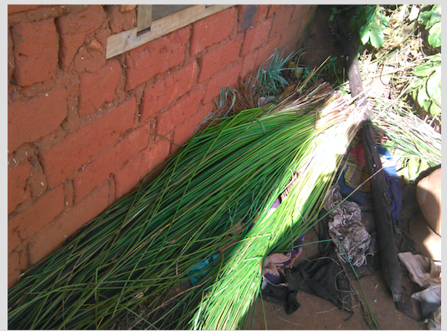

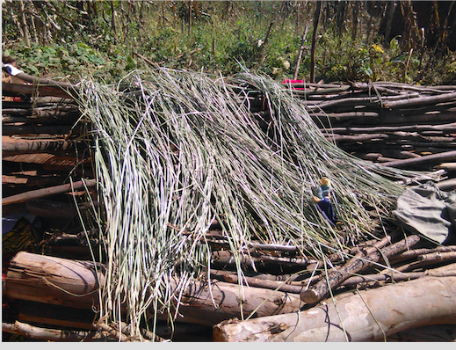

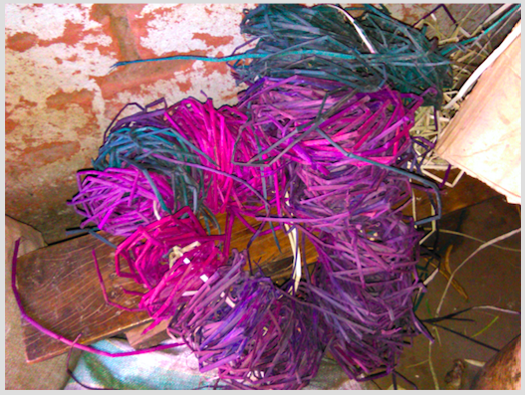

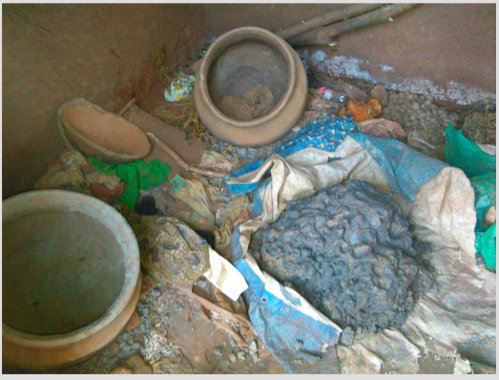

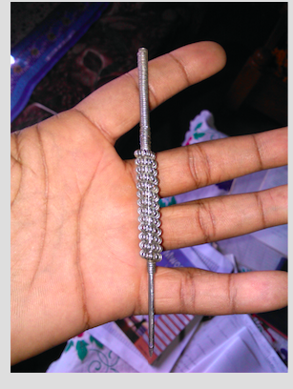

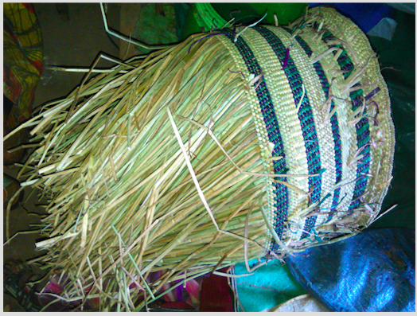

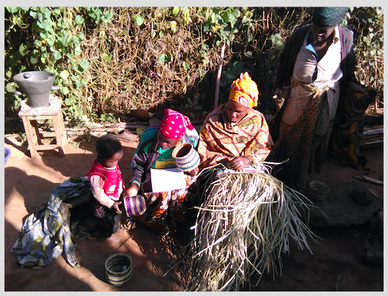

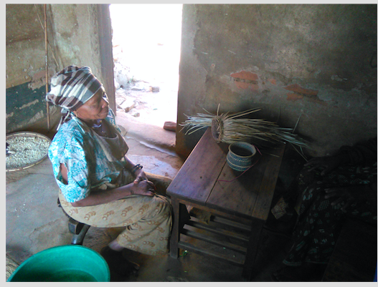

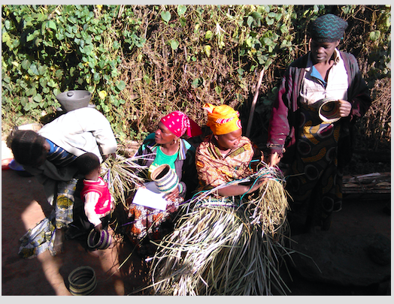

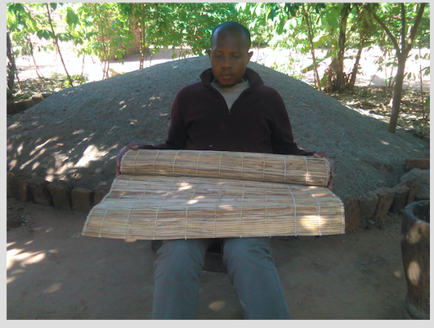

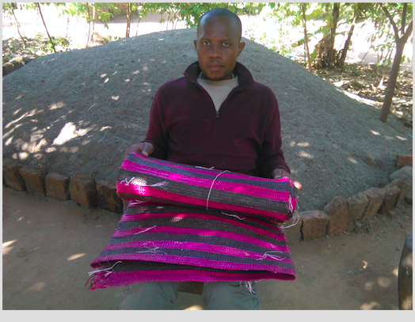

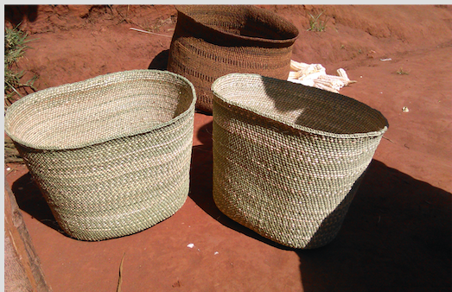

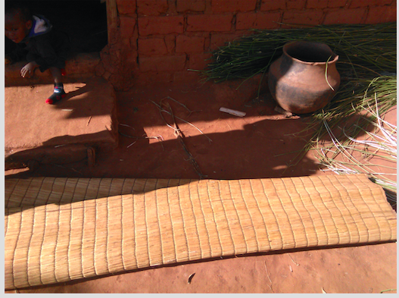

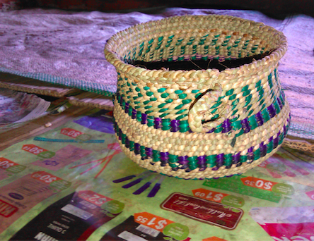

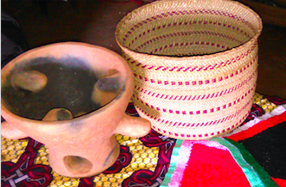

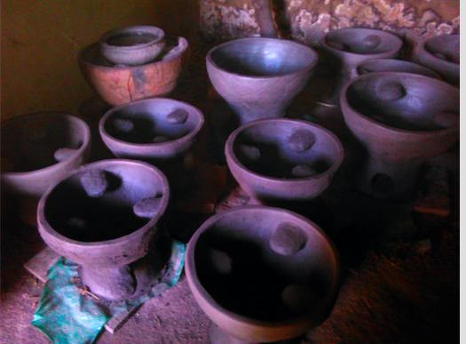

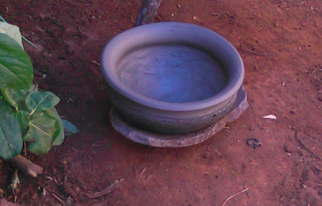

B. Handicrafts from Selected Countries:

KENYA

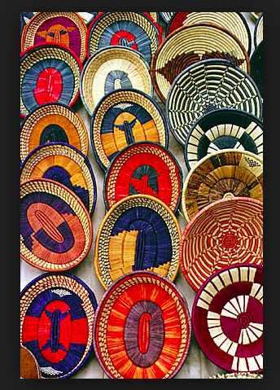
https://www.pinterest.com/

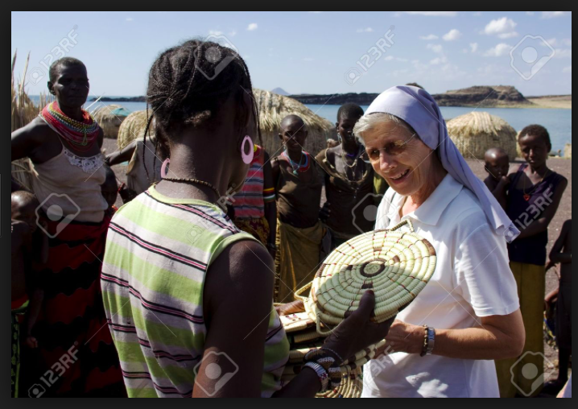
https://www.123rf.com/photo_21416843_lake-turkana

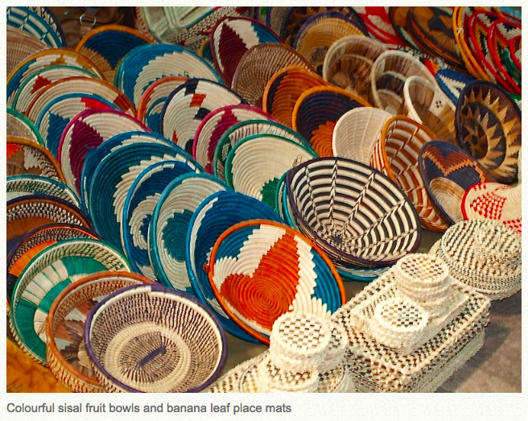
http://tijarabeach.com/maasai-market-nairobi

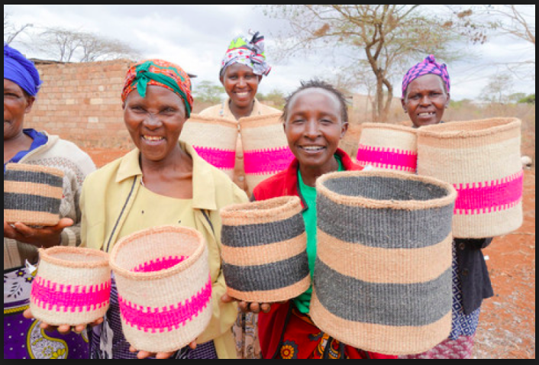
https://www.thebasketroom.com/pages/kenya

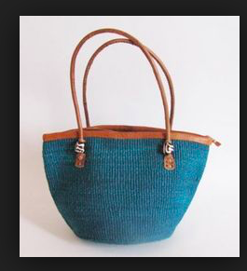
https://www.pinterest.com/

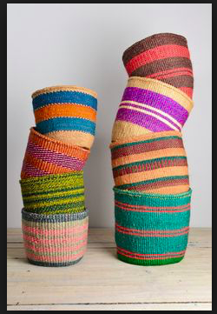
https://www.pinterest.com/
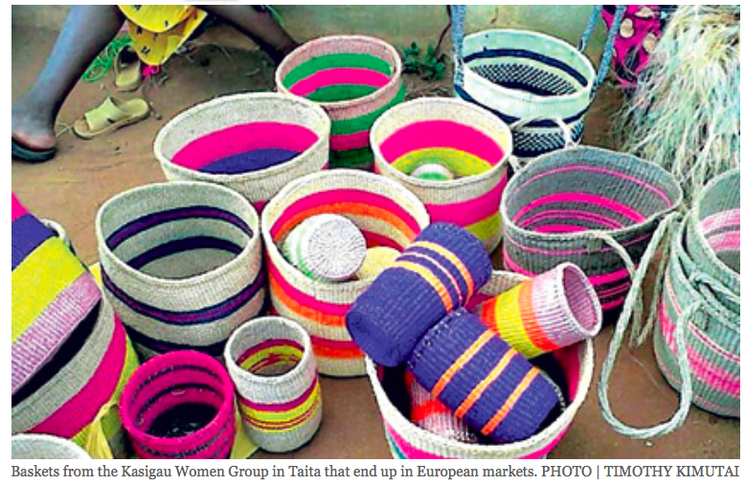
http://www.nation.co.ke/

RWANDA:

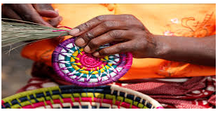
http://amahoro-tours.com/agaseke-handicrafts-lessons/

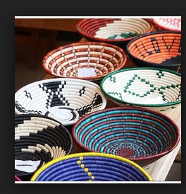
http://www.kariburwanda.com/

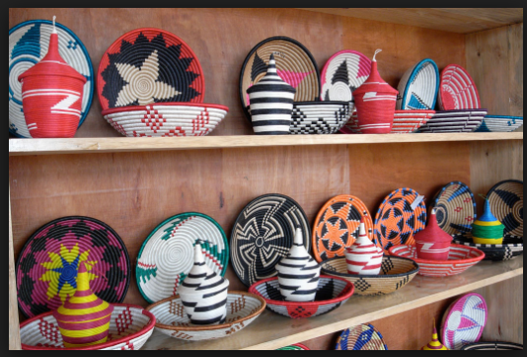
http://www.ukumbi.org/projects/agaseke.html

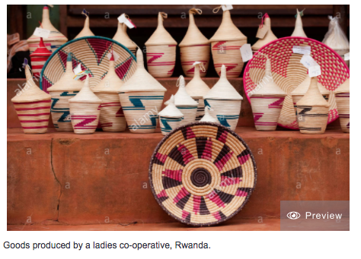
http://www.alamy.com/

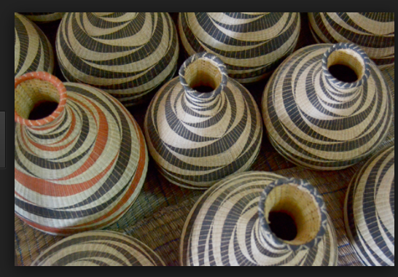
http://www.lionessesofafrica.com/

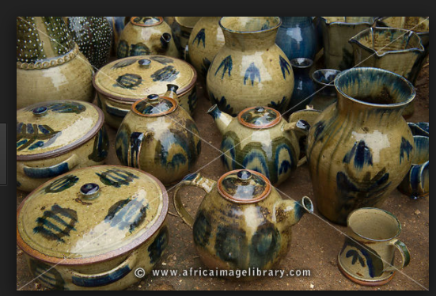
http://www.africaimagelibrary.com/

UGANDA

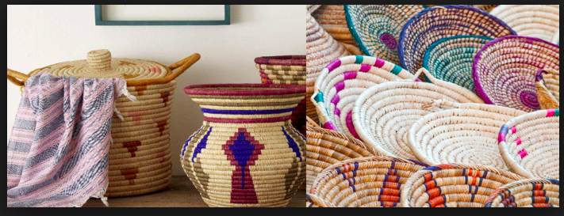
http://www.primeugandasafaris.com/

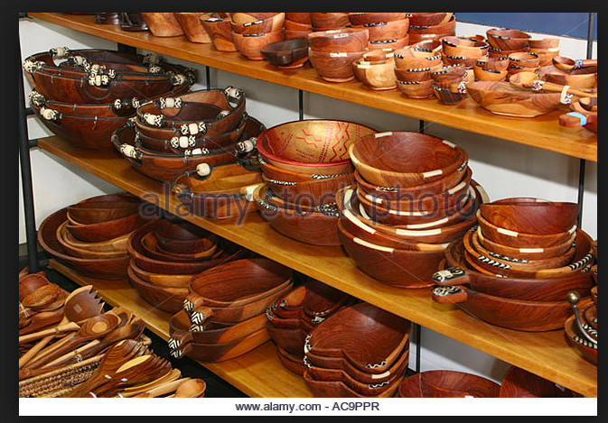
http://www.alamy.com/

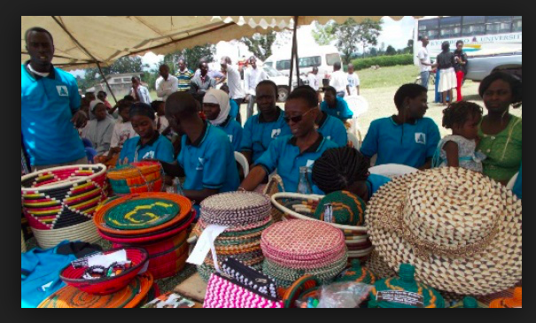
http://www.cbm.org/

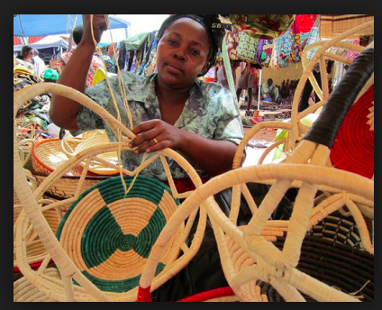
http://www.aboutuganda.com/

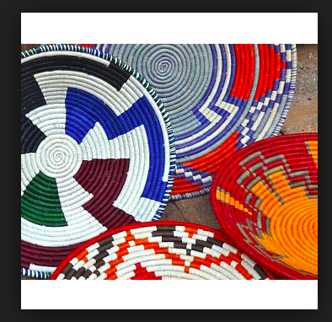
http://www.linkingmakerandmarket.com/

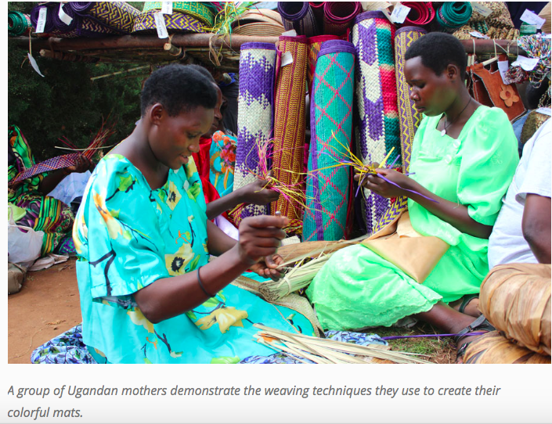
https://blog.unbound.org/

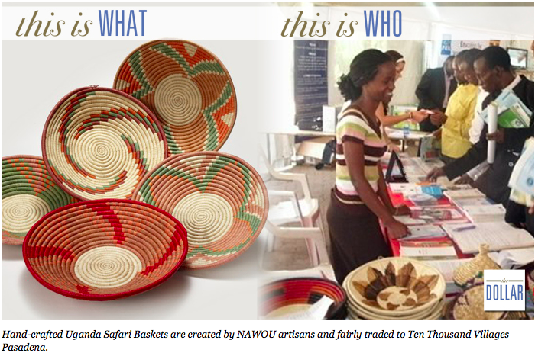
https://thedollarapp.wordpress.com/

ZAMBIA

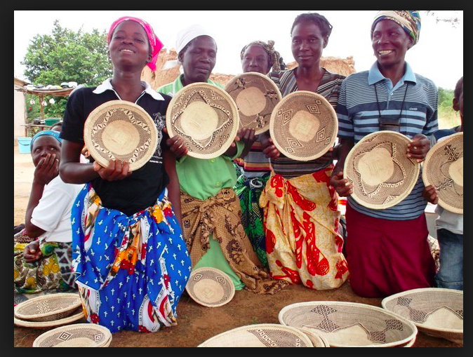
http://garlandmag.com/article/binga-baskets-and-other-treasures-of-zimbabwean-craft/

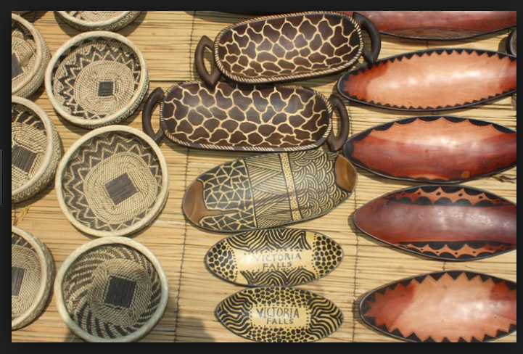
http://thebestofzambia.com/orgs/kabwata-cultural-village/

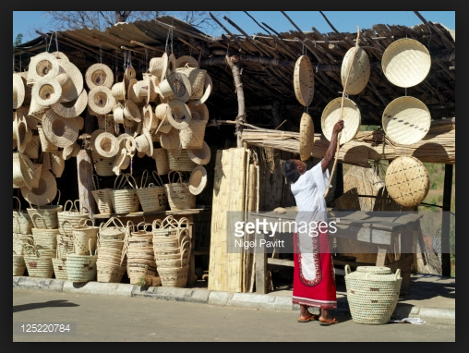
http://www.gettyimages.com/

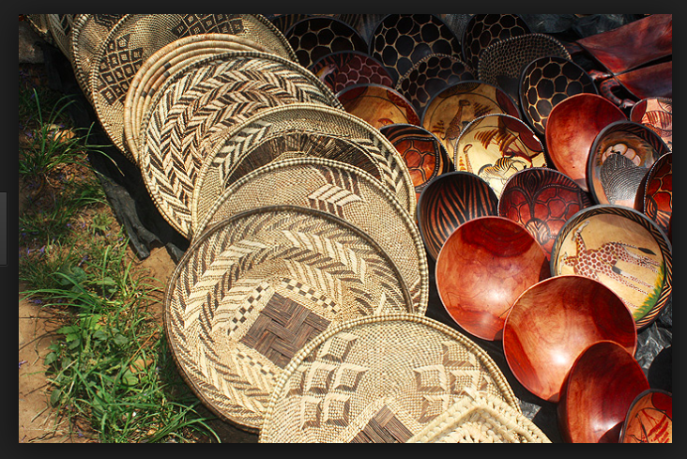
http://thebestofzambia.com/orgs/kabwata-cultural-village/

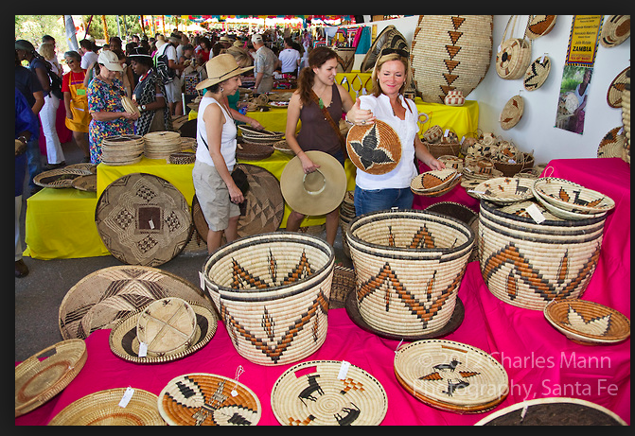
Shoppers at the Santa Fe International Folk Art Market can choose from items made from countries all over the world, including these baskets made in Zambia
http://charlesmann.photoshelter.com/

ZANZIBAR
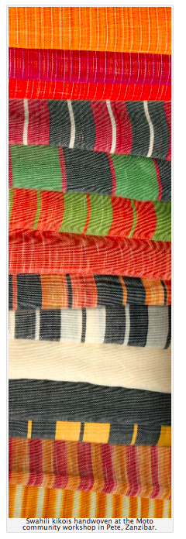
https://motozanzibar.wordpress.com/

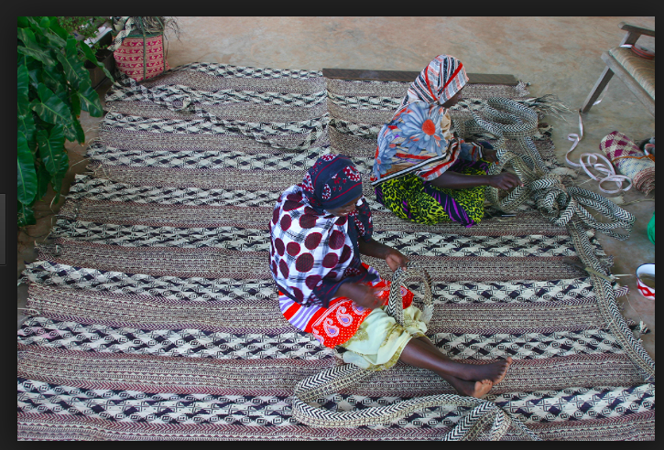
https://motozanzibar.wordpress.com/

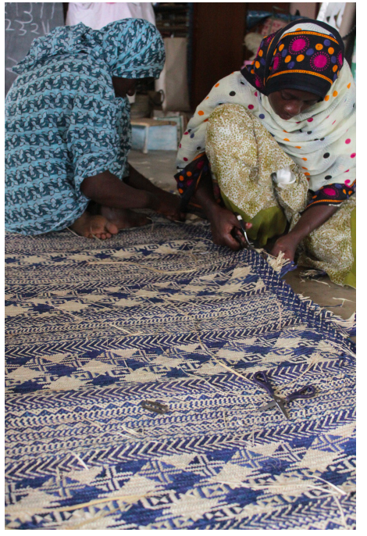
https://motozanzibar.wordpress.com/

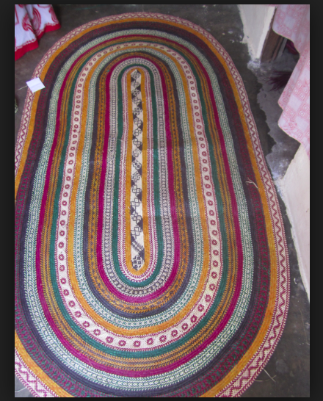
https://motozanzibar.wordpress.com/

Source: Pictures taken during fieldwork (June 2016).
Sources: http://amahoro-tours.com/agaseke-handicrafts-lessons/; http://www.primeugandasafaris.com/uganda/traditional-crafts-of-uganda.html

