Illustrations, Tables and Figures
Table 1: Losses related to storage conditions in Tanzania (in percent of total maize losses)
Type of Loss | Type of farm scale
 | Small | Large
Lack of storage | 13 | 13
Pest infestation | 40 | 50
Poor quality of storage facilities | 23 | 25
Source: World Bank, 2009

Table 2: Food Crops Preservation Practices in Rural Areas
Area | Crop(s) Preserved | Inputs/Local Herbs Used
Kilosa | Cassava | Salting
 | Maize | Kitchen ash; or
 |  | Burnt rice ash
Moshi Rural | Bean or maize | Chilli pepper; or
 |  | Wild tobacco; or
 |  | Concoction of chilli pepper and mabangi mwitu leaves; or
 |  | Concoction of urutupa and mabangi mwitu leaves; or
 |  | Concoction of urutupa and chilli pepper; or
 |  | Kitchen ash
Kasulu | Bean or maize | mshindwi tree ash; or
 |  | a mixture of chilli pepper and mshindwi tree ash; or
 |  | a mixture of chilli pepper and mtundu tree ash; or
 |  | a concoction of chilli pepper and ash from any tree, or
 |  | Kitchen ash
 | Peas | concoction of chilli pepper and ash from any tree
Mpwapwa | Bean or maize | msakasaka plant leaves; or
 |  | ground neem leaves; or
 |  | kajashi tree ash; or
 |  | mluku tree leaves; or
 |  | a mixture of msonobali and chilli pepper, or
 |  | Kitchen ash or goat dung ash or maize cobs ash
 | Sorghum | Kitchen ash or goat dung ash or maize cobs ash
Karagwe | Maize | kajai plant leaves; or
 |  | kajashi tree ash; or
 |  | masaka plant leaves; or
 |  | the mixture of kaswagala and kajai tree leaves; or
 |  | Kitchen ash or mud or dry cow dung or anthill soil
 | Sorghum | kajai plant leaves; or
 |  | mluku tree leaves
Songea Rural | Bean or Maize | Kitchen ash
Source: Adapted from Lwoga et al., 2010

Table 3: Gender Responsibilities in Agriculture
Activity | % of hours spent per day
 | Male | Female
Land preparation and planting | 44.2 | 55.8
Weeding | 45.0 | 55.0
Ridging, fertilizing and other non-harvest activities | 43.0 | 57.0
Harvesting | 45.0 | 55.0
Aggregate Agriculture | 44.6 | 55.4
Source: National Panel Survey (NPS) 2012-2013

Table 4: Percentage distribution of employed individuals aged 15+ years by selected industry and sex, Tanzania Mainland, 2014
Industry | Male | Female | Gender Gap  (in favour of females)
Agriculture, forestry and fishing | 64 | 69.9 | 5.9
Accommodation and food service activities | 1.4 | 6.5 | 5.1
Transportation and storage | 5.0 | 0.2 | -4.8
Construction | 4.0 | 0.1 | -3.9
Mining and quarrying | 1.7 | 0.4 | -1.3
Manufacturing | 3.6 | 2.6 | -1.0
Administrative and support service activities | 1.0 | 0.3 | -0.7
Wholesale and retail trade; repair of motor vehicles and motorcycles | 12.4 | 12.8 | 0.4
Human Health and social work activities | 0.7 | 1.0 | 0.3
Education | 2.1 | 2.1 | 0.0
Others | 4.1 | 4.1 | 0.0
Source: ILFS (2014)

Table 5: Distribution of sample size according to village
Region | District | Village | Number
Dodoma | Bahi | Bahi | 3
 |  | Bahi Sokoni | 4
 |  | Kigwe | 8
 | Kongwa | Kibaigwa | 21
Iringa | Iringa Rural | Igula | 3
 |  | Ndiwili | 6
 |  | Tagamenda | 8
 | Kilolo | Luhindo | 5
 |  | Lulanzi | 4
Mbeya | Kyela | Ikambi | 20
 | Mbarali | Itamboleo | 14
 | Mbeya Rural | Inyala | 6
 |  | Makwenje | 1
Total |  |  | 103
Source: Survey Data

Table 6: Description of variables used in estimation
Variable | Description | Hypothesis
logfarmsize | size of land (in acres) cultivated by the household (log) | regressand
age | age of the respondent in years | +
accland | 1 if respondent considers easy access to land, 0 otherwise | +
mrtstatus | 1 if the respondent is married, 0 otherwise | +
edn | 1 if respondent's highest education level is primary and above, 0 otherwise | +
nchild | 1 if household has 4+ children, 0 if has 0-3 children | +
disstrgchoice | dissatisfaction with storage facilities in use (1 if dissatisfied, 0 otherwise) | -

Table 7: Distribution of sample size according to age
Age | 20-29 | 30-39 | 40-49 | 50-59 | 60-69 | 70+ | Total
Sample | 19 | 28 | 30 | 13 | 7 | 6 | 103
Source: Survey Data.

Table 8: Decision making on various aspects of farming (%)
 | Husband/  Male | Wife/  Female | Husband & Wife | Children & Wife
Food crops selling | 10.8 | 38.6 | 47.0 | 3.6
Time to sell | 15.0 | 36.3 | 45.0 | 3.8
Revenue keeper from sale of food crops | 16.3 | 67.5 | 13.8 | 2.5
How revenue should be spent | 17.7 | 36.7 | 41.8 | 3.8
Source: Survey Data

Table 9: Households staple food allocation to storage and market
 | As Percentage of Produced Quantities
Staple Food Crops | Stored | Sold
Maize | 60.6 | 39.1
Beans | 43.2 | 56.8
Paddy | 55.0 | 45.0
Sorghum | 72.7 | 27.3
Millet | 67.5 | 32.5
Cassava | 54.9 | 45.1
Sweet Potatoes | 53.0 | 47.0
Source: National Sample Census of Agriculture, 2007/08
Figure 1: Regional distribution of household average annual income from food crops selling

Source: Survey Data
Figure 2: Percentage distribution of access to land by region

Source: Survey Data
Table 10: Primary food processing methods
Method | Sample crops | Mechanism/Operationalization
Threshing | Groundnuts, Beans, Sorghum, Paddy, Sunflower, Millet | -Hitting with sticks
Winnowing | Beans, Sorghum, Paddy, Sunflower, Millet | -Through throwing the grain into the air using a sieve/winnower  -Falling the grains from the air using a basket
Shelling | Maize | -Manually using hands  -Hitting with sticks
Peeling | Cassava, Sweet Potatoes, Peas | -Using hands and knife
Drying | Cassava, Groundnuts, Maize, Paddy, Sunflower, Vegetable, Eggplant | -Exposure to sunlight by spreading in a thin layer or on the ground  -Sweet potatoes and cassava after being cut into small pieces and soaked are then exposed to sun  -Vegetables (such as mchicha) are partially boiled before being exposed to sun  -Eggplant after being peeled and cut into small pieces, is then rinsed with water and exposed to sun for drying
Source: Survey Data.

Figure 3: A research assistant with a woman who is processing cassava (peeling) for storage
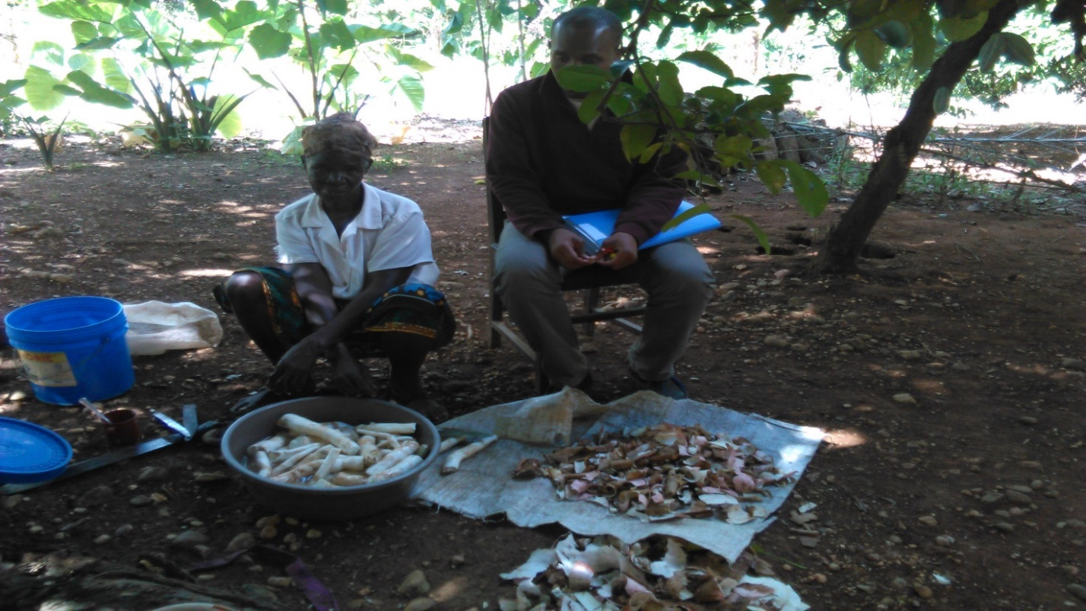

Figure 4: Drying of vegetables before storage for durability
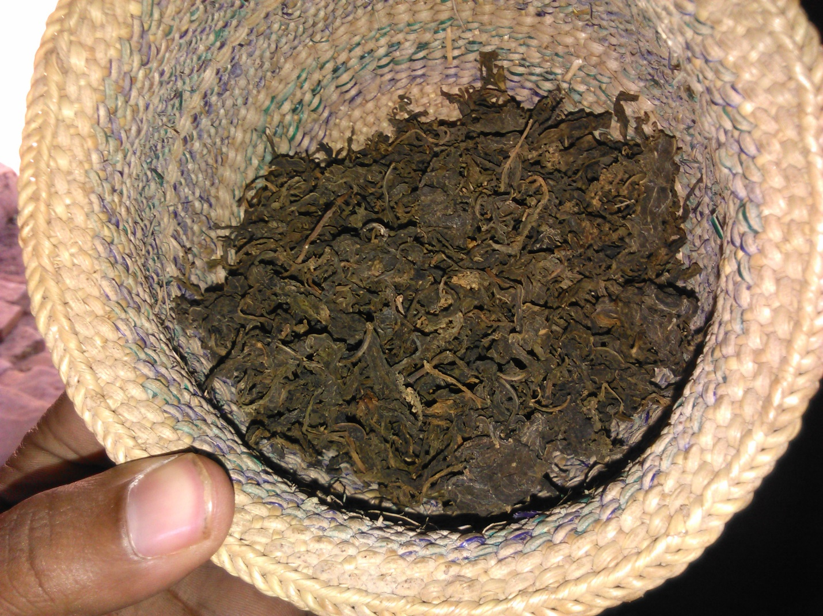

Figure 5: Sun drying by spreading on the ground
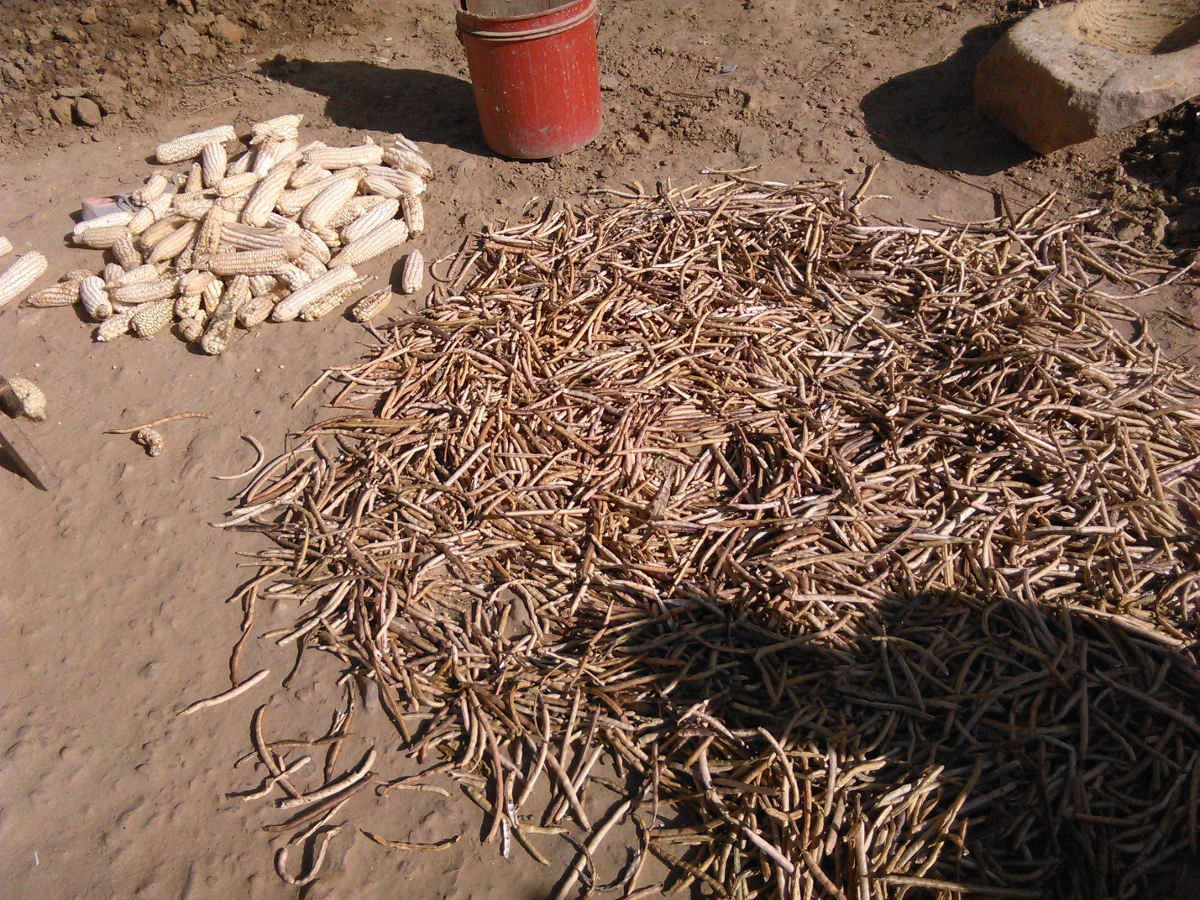
Table 11: Commonly used food storage structures
Storage facility | Adoption  (%) | Duration of Storage  (Months)
Granary (Kihenge) | 4 | 7
Sack/bag | 95 | 9
Aerial/ceiling: hanging from tight lines above fire places | 1 | 6
Underground storage | 3 | 7
Clay pots/baskets/plastic tins | 3 | 8
Source: Survey Data

Figure 6: Maize stored in a granary
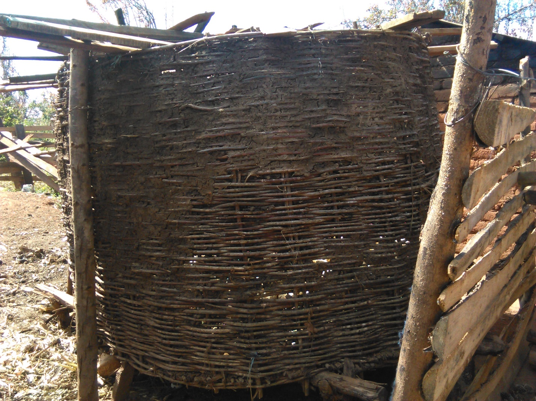

Table 12: Household food storage reasons
Purpose of storage | Dodoma | Iringa | Mbeya
Food for household | 100.0 | 100.0 | 100.0
Seed for planting | 84.9 | 34.8 | 59.3
To sell at higher price later | 39.4 | 43.5 | 55.6
To meet future cash needs | 15.2 | 73.9 | 59.3
Others | 9.1 | 0.0 | 0.0
Source: Survey Data

Table 13: Food storage protectants used in surveyed areas
 | Storage Protectant
Storage facility | Artificial/Industrial Chemicals  (Spraying/Dusting) | Neem Leaves  (mwarobaini) | Cowdung/Ashes/Magadi | Smoking
Granary (Kihenge) |  | 0 |  | 0
Sack/Bag |  |  |  | 0
Aerial/Ceiling | 0 | 0 | 0
Underground Storage | 0 | 0 | 0 | 0
Clay pots/Baskets/Plastic tins | 0 | 0 | 0 | 0
Source: Survey Data
Figure 7: Farmers reported food losses

Figure 8: Damaged maize from storage
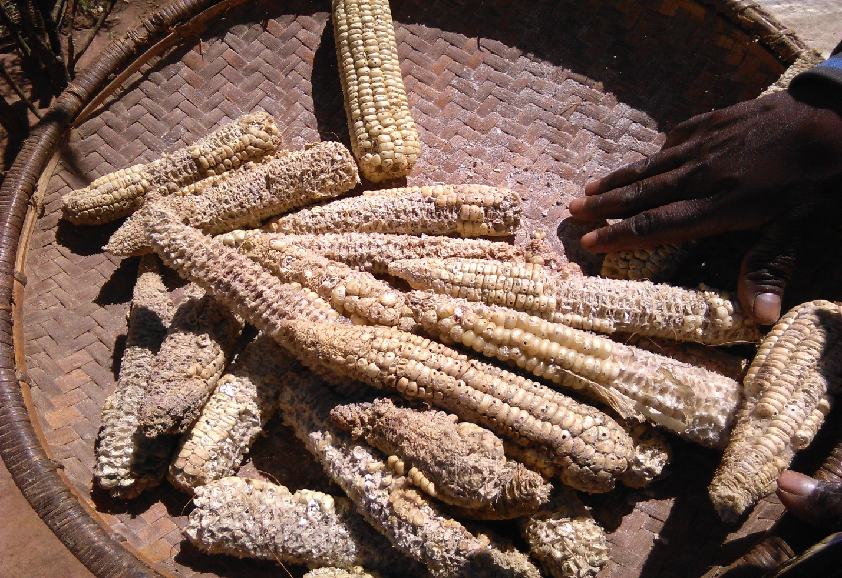

Table 14: Regression results of employment model
Variable | Coefficient | Robust  Std. Err. | P-Values
age | 0.00026152 | 0.0052791 | 0.961
mrtstatus | 0.32657193* | 0.1345515 | 0.017
edn | -0.07750317 | 0.1625508 | 0.635
nchild | 0.30182096* | 0.1403690 | 0.034
accland | -0.04790627 | 0.1561152 | 0.760
disstrgchoice | -0.37221404* | 0.1533397 | 0.017
_cons | 0.87596429** | 0.2968106 | 0.004
Source: Survey Data legend: * p<0.05; ** p<0.01
Table 15: Respondents suggested improvements for better food storage
Suggested improvements | Suggested Storage facility |  | Percentage (%)
Provision of safe and secure storage facilities | Use of drums | 19.1 % | 55.8
 | Hermetic storage bags | 13.2 %
 | Use of vihenge | 10.3 %
 | Others | 13.2%
Manufacture of effective storage protectants | -Nil- | -Nil- | 32.4
A method that does not require to put/add artificial protectants | -Nil- | -Nil- | 11.8
Source: Survey Data

