Table 1: Distribution of working age population, 15+ years by sex and area
Note: Proportionate distributions are relative to the total population of the country’s workforce
Source: ILFS (2014), Analytical Report

Table 2: Mean monthly income (Tsh.) of paid and self-employed persons, 15+ years by age group and sex
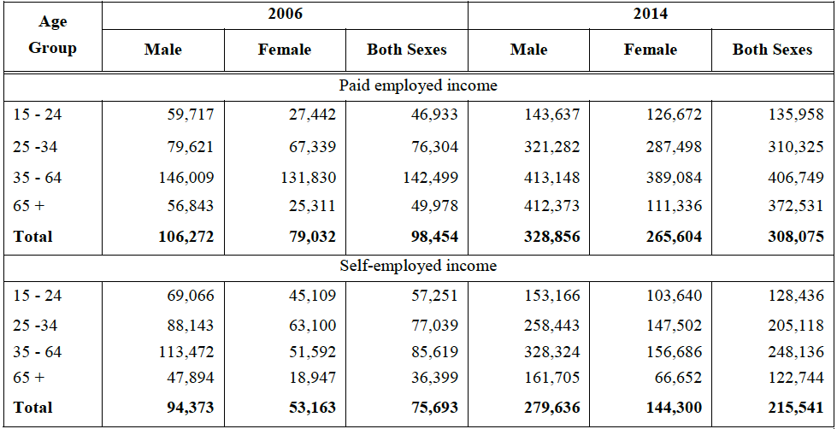
Source: ILFS (2006 & 2014)

Table 3: Distribution of employed population aged, 15+ years by sector and sex, 2014
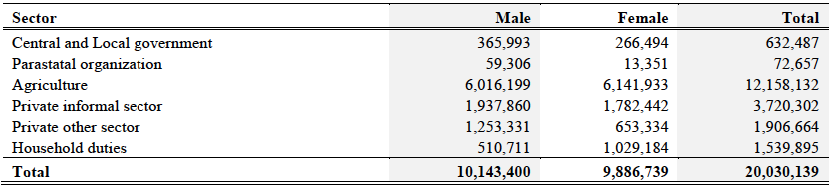
Source: ILFS (2014)

Table 4: Distribution of employed population, 15+ years in informal sector by level of education and sex, 2014
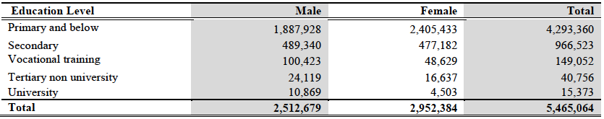
Source: ILFS (2014)

Table 5: Sample distribution by villages

Chart 1: Age profile of respondents

Table 6: Educational background of respondents

Table 7: Marital status of respondents

Table 8: Main activity of Maasai women respondents – by proportions

Table 9: Main types of body ornamental products produced by Maasai women in Arusha
Note: In column 2 is number of women producing each type, respectively, out of 94 who revealed participation in production.

Chart 2: Maasai women sales by market category

Table 10: Descriptive statistics of incomes from body ornamental products (US$)
Note: Exchange rate source is BOT Annual Report 2015/16 (Tsh. 2,192.4 at end June 2016)

Chart 3: Normal quantile plot and frequency distribution
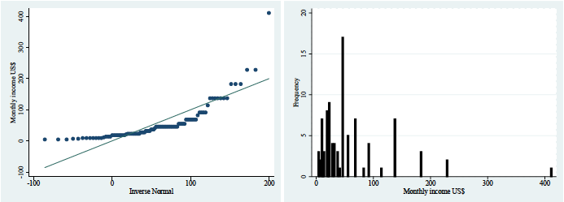

Table 11: Proportions of observed distribution of respective exogenous variables

Table 12: Linear survey regression results

Table 13: Challenges to production and marketing of ornamental products
Note: The numbers and proportion are out of 90 respondents who answered a question on respective hindering factors.

Table 14: Maasai women training and knowledge transfer
Note: Numbers and proportions are out of 91 respondents who answered a question on education and knowledge transfer

