**HARNESSING INDIGENOUS KNOWLEDGE SYSTEMS THROUGH CREATION OF EMPLOYMENT FOR RURAL WOMEN IN TANZANIA: *Opportunities and Challenges***

**A. Tables**

**Table 1: Working Population Aged 15 years and above by Type of Employment**

|  |  |  |  |  |  |  |  |  |  |  |
| --- | --- | --- | --- | --- | --- | --- | --- | --- | --- | --- |
|  | 2006 | | | | | 2014 | | | | |
|  | **Total** | Male | Female | Urban | Rural | **Total** | Male | Female | Urban | Rural |
|  | Standard definition | | | | | | | | | |
| Informal employment* | **93.3** | 90.2 | 96.3 | 82.1 | 97.0 | **92.1** | 89.4 | 94.9 | 82.5 | 97.3 |
| Vulnerable employment | **88.6** | 83.5 | 93.4 | 69.3 | 95.0 | **87.1** | 83.2 | 91.1 | 71.6 | 95.5 |

**Source:** ILO, 2010 and ILFS, 2014

*Informal employment includes contributing to family workers, own-account workers on own farm, paid employees and self-employed workers in informal enterprises or household units.

**Table 2: Responding rural communities in Hanang**

|  |  |  |
| --- | --- | --- |
| **Village/Area** | **Frequency** | **Percent** |
| Balangdalalu | 14 | 14 |
| Dawari | 2 | 2 |
| Dirma | 19 | 19 |
| Dumbeta | 2 | 2 |
| Ganana | 11 | 11 |
| Kateshi | 11 | 11 |
| Lamay | 3 | 3 |
| Ming'enyi | 27 | 27 |
| Mogitu | 4 | 4 |
| Mureru | 4 | 4 |
| Muungano | 3 | 3 |
| **Total** | **100** | **100** |

**Table 3: Marital Status and Household headship**

|  |  |  |  |
| --- | --- | --- | --- |
| Marital status | Gender of the head of  household | | Total |
|  | Female | Male |  |
| Single | 7 | 0 | 7 |
| Married | 47 | 23 | 70 |
| Divorce/separated | 4 | 0 | 4 |
| Widows | 19 | 0 | 19 |
| **Total** | **77** | **23** | **100** |

**Table 4: Educational levels of respondents**

|  |  |  |
| --- | --- | --- |
| **Level of Education** | **Frequency** | **Percent** |
| No formal education | 60 | 60 |
| Primary school | 28 | 28 |
| Secondary school | 10 | 10 |
| Tertiary school | 2 | 2 |
| **Total** | **100** | **100** |

**Table 5: Respondents by Economic Activities and Occupations**

|  |  |  |
| --- | --- | --- |
| **Economic Activity** | **Frequency** | **Percent** |
| Crop farming | 72 | 72 |
| Livestock | 24 | 24 |
| Business | 18 | 18 |
| **Main occupation** |  |  |
| Skin and cloth making | 6 | 6.6 |
| Farming (crop/livestock) | 75 | 82.4 |
| Trader | 10 | 11 |
| **Secondary Occupation** |  |  |
| Skin and cloth making | 56 | 80 |
| Farming (crop/livestock) | 11 | 15.7 |
| Trader | 3 | 4.3 |

**Table 6: Chemicals and Non-chemicals Inputs Sources**

|  |  |  |
| --- | --- | --- |
|  | Chemicals | Non-chemicals |
| Traditionally made | 25% | 52% |
| Nearby markets | 27% | 76% |
| Within the district | 20% | 60% |
| Outside the district | 3% | 20% |
| Get them through SIDO | 0 | 7% |
| Imported | 0 | 0 |

**Table 7: Level of production in the last 1 month (May)**

|  |  |
| --- | --- |
| **Item** | **Units** |
| Dresses/gowns | 35 |
| Skirts | 38 |
| Jackets | 1 |
| Others | 101 |

**Table 8: Current production challenges**

|  |  |  |
| --- | --- | --- |
|  | Frequency | Percent |
| Shortage of chemical products | 9 | 9% |
| Technology limiting factors | 32 | 32% |
| Expensive inputs | 74 | 74% |
| Lack of markets | 69 | 69% |

**Table 9: Current Marketing Challenges**

|  |  |
| --- | --- |
|  | Percent |
| Price not good enough in the market | 52% |
| Cheating by middlemen | 9% |
| Distance from the markets (good markets segments not reachable) | 52% |
| Communication is a hindering factor | 29% |
| Low quality products | 2% |

**Table 10: Descriptive statistics of monthly average incomes from sales** (TZS)

|  |  |  |  |  |
| --- | --- | --- | --- | --- |
|  | Percentiles | Smallest |  |  |
| 1% | 8,000 | 8,000 |  |  |
| 5% | 20,000 | 16,000 |  |  |
| 10% | 30,000 | 18,000 | Obs | 71 |
| 25% | 45,000 | 20,000 |  |  |
|  |  |  |  |  |
| 50% | 70,000 |  | Mean | 143,232.4 |
|  |  | Largest | Std. Dev. | 156,418.6 |
| 75% | 200,000 | 40,000 |  |  |
| 90% | 360,000 | 40,000 | Variance | 2.450110 |
| 95% | 400,000 | 70,000 | Skewness | 2.036134 |
| 99% | 800,000 | 80,000 | Kurtosis | 7.614298 |

Exchange rate end June 2016 (TZS/$ 2,192.4)

**Table 11: Who decide when the savings will be spent and what for?**

|  |  |  |
| --- | --- | --- |
|  | Frequency | Percent |
| Myself/female | 62 | 84.9% |
| My husband/male | 4 | 5.5% |
| Jointly with my husband | 5 | 6.9% |
| Marketing | 2 | 2.7% |

**Table 12: Group/organisation Membership benefits**

|  |  |
| --- | --- |
|  | Percent |
| Source of capital | 31% |
| Input supply | 19% |
| Training | 37% |
| Marketing | 29% |

**Table 13: Who is traditionally allowed to inherit land/property or other assets**

|  |  |  |
| --- | --- | --- |
|  | Frequency | Percent |
| All family members | 8 | 8.2% |
| Male family members only | 73 | 74.5% |
| Female family members only | 3 | 3.1% |
| Children | 14 | 14.3% |

**Table 14: The extent to which generated incomes affected their lifestyle**

|  |  |  |
| --- | --- | --- |
|  | Frequency | Percent |
| Ability to buy food for your family | 34 | 34% |
| Ability to educate the children | 42 | 42% |
| Ability to ensure adequate health care for your family | 43 | 43% |
| Voice in decision making (women empowerment) | 54 | 54% |

**B. Figures**

**Figure 1: Barabaig Women Traditional Leather and non-Leather Products**

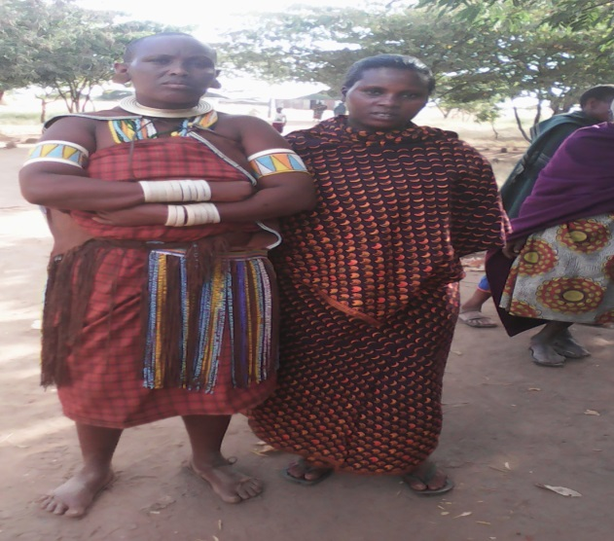 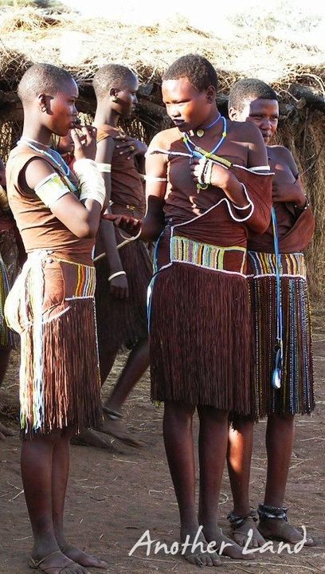

*Figure 1(a): Barabaig women on traditional gown Figure 1(b): Barabaig Girls on traditional dresses*

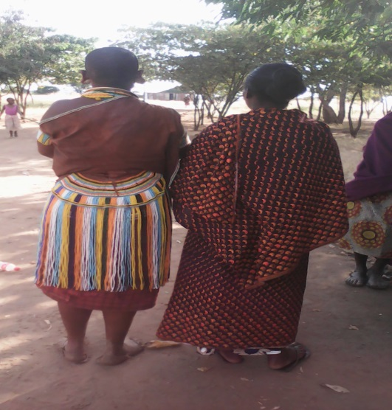 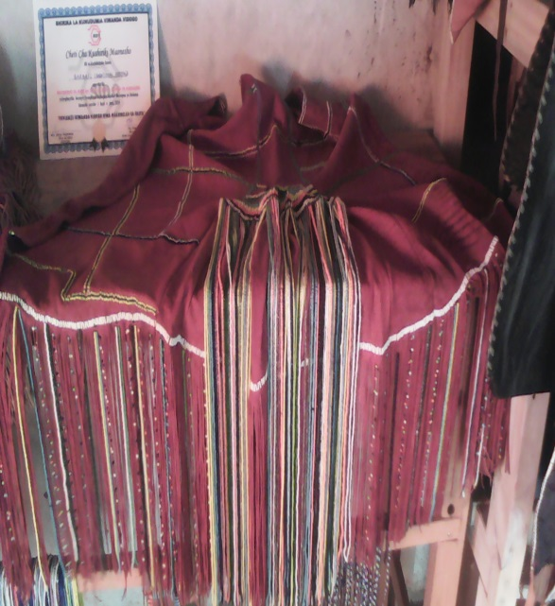

Figure 1(c): Barabaig Women Figure 1(d): Barabaig Gown

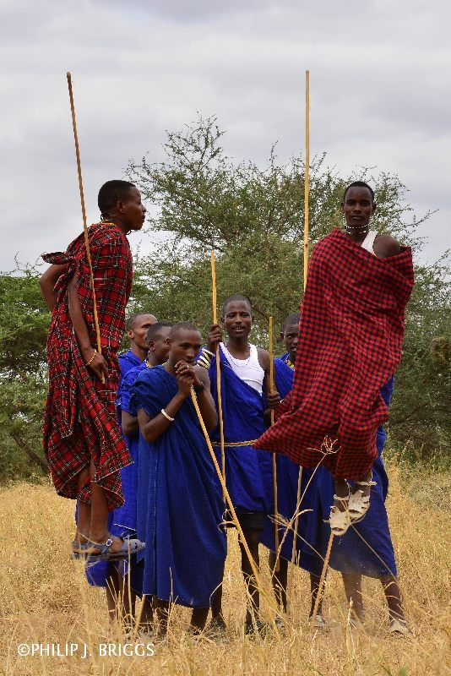 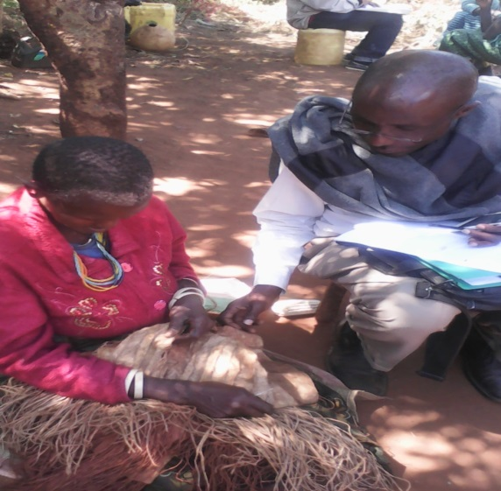

*Figure 1(e): Barabaig Boys on traditional blankets* *Figure 1(f): Making a Barabaig traditional skirt*

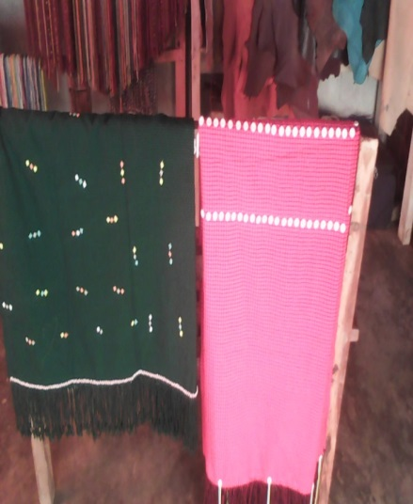 [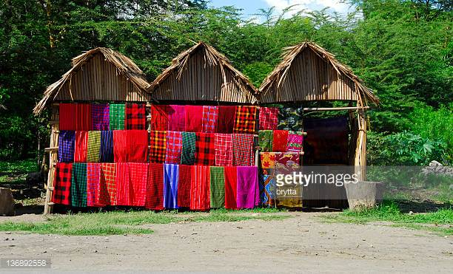](http://www.google.com/url?sa=i&rct=j&q=&esrc=s&source=images&cd=&cad=rja&uact=8&ved=0ahUKEwin2t-oiqXWAhUH0xQKHXuSBbkQjRwIBw&url=http%3A%2F%2Fwww.gettyimages.com%2Fphotos%2Ftanzania%3Fpage%3D2&psig=AFQjCNHBlT5oXOL4vKNliEuy30xdKHfCqw&ust=1505492366671645) 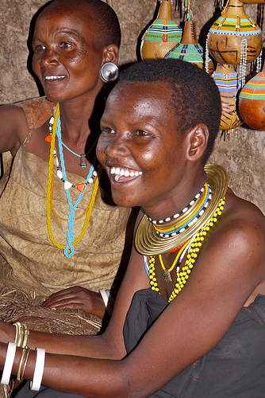

*Figure 1(g): Other Barabaig traditional products (vikoi, traditional blankets, and bracelets)*

