**HARNESSING INDIGENOUS KNOWLEDGE SYSTEMS THROUGH CREATION OF EMPLOYMENT FOR RURAL WOMEN IN TANZANIA: *Opportunities and Challenges***

**Figure 1: Barabaig Women Traditional Leather and non-Leather Products**

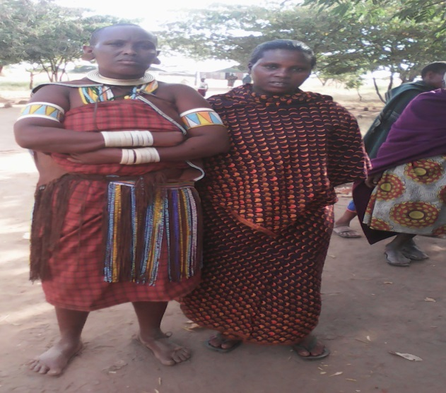 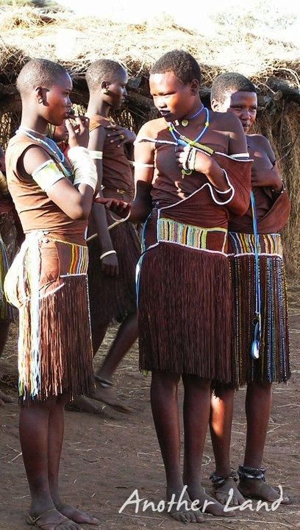

*Figure 1(a): Barabaig women on traditional gown Figure 1(b): Barabaig Girls on traditional dresses*

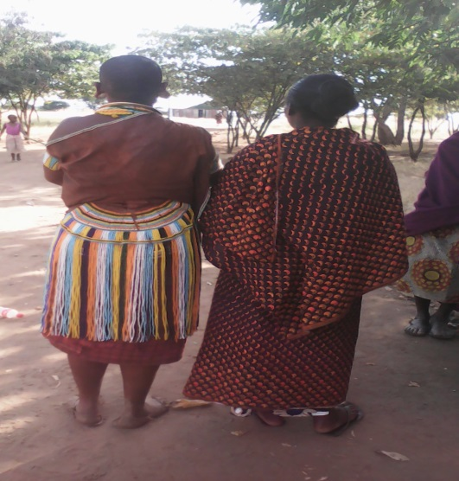 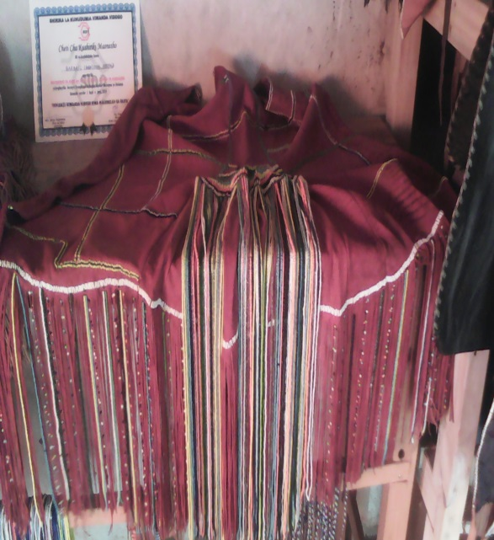

Figure 1(c): Barabaig Women Figure 1(d): Barabaig Gown

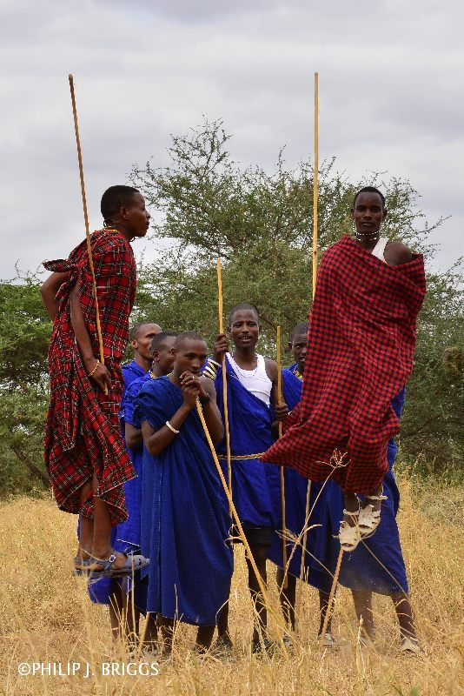 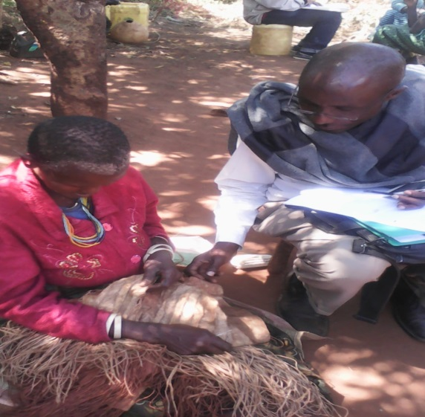

*Figure 1(e): Barabaig Boys on traditional blankets* *Figure 1(f): Making a Barabaig traditional skirt*

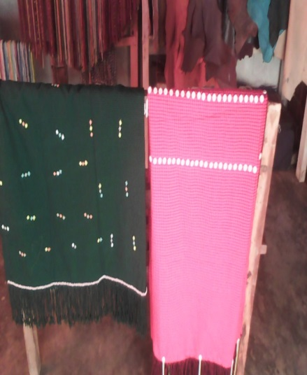 [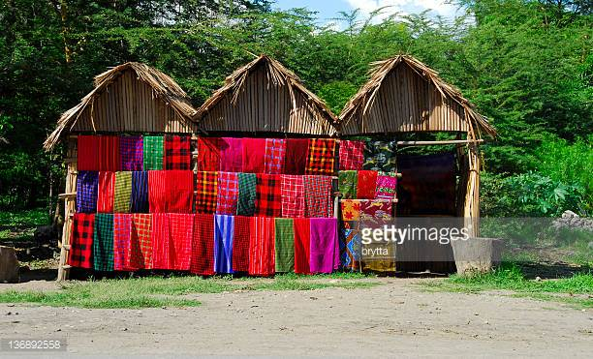](http://www.google.com/url?sa=i&rct=j&q=&esrc=s&source=images&cd=&cad=rja&uact=8&ved=0ahUKEwin2t-oiqXWAhUH0xQKHXuSBbkQjRwIBw&url=http%3A%2F%2Fwww.gettyimages.com%2Fphotos%2Ftanzania%3Fpage%3D2&psig=AFQjCNHBlT5oXOL4vKNliEuy30xdKHfCqw&ust=1505492366671645) 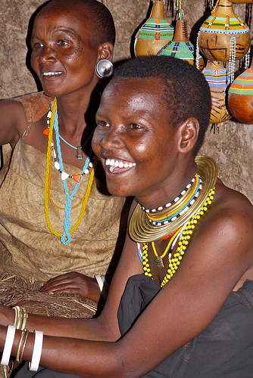

*Figure 1(g): Other Barabaig traditional products (vikoi, traditional blankets, and bracelets)*

